COMSOL Multiphysics Pvt. Ltd.  Esquire Center, C-Block, 3rd Floor  No. 9, M.G. Road, Bangalore 560001, India  Phone: +91-80-2559-7799  Web: www.comsol.com  Blog: www.comsol.com/blogs | Editor Contact  Betsy Chacko, Marketing Executive  betsy@comsol.com
COMSOL Partners with IEEE to Sponsor AIyeHum 2013
The IEEE Bangalore Section sponsors the All IEEE R10 Young Engineer’s Humanitarian Challenge in partnership with COMSOL. For more information about COMSOL, visit us at: http://www.comsol.com. For contest details, visit http://ieeehumanitarian.com.

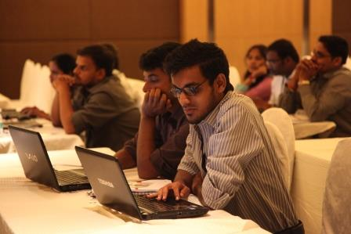
Bangalore, India (June 4, 2013) — COMSOL India has partnered with the IEEE Bangalore Section to sponsor the All IEEE R10 Young Engineer’s Humanitarian Challenge, AIyeHum 2013. The contest is intended for all professionals and students under the age of 35 from Asia-Pacific (IEEE R10) countries and from any science or engineering field.
Vineet Dravid, Managing Director of COMSOL offices in Bangalore and Delhi, India, says "We are happy to partner with IEEE R10 in this design contest. This contest provides a good platform for young engineers to present product ideas designed and optimized specifically for Asian consumer needs, and we welcome such initiatives."
AIyeHum is a project-contest designed to encourage young scientists and engineers to solve real-world problems within the Asia-Pacific community. Particular emphasis is on the implementation of innovative technology including distribution methods to reach the intended beneficiaries.
Each team that has been selected will receive funding for their projects and guidance from a mentor from either industry or academia. Contest winners will be selected by a panel of experts and the top contestant may have the opportunity to present their work at an IEEE Humanitarian Conference. For more details visit: http://ieeehumanitarian.com.
About COMSOL
COMSOL provides simulation software for product design and research to technical enterprises, research labs, and universities through over 17 offices and a distributor network all over the world. Its flagship product, COMSOL Multiphysics®, is a software environment for modeling and simulating any physics-based system. A particular strength is its ability to account for coupled or multiphysics phenomena. Add-on products expand the simulation platform for electrical, mechanical, fluid flow, and chemical applications. Interfacing tools enable the integration of COMSOL Multiphysics simulation with all major technical computing and CAD tools on the CAE market.
~
COMSOL, COMSOL Multiphysics, Capture the Concept, COMSOL Desktop, and LiveLink are either registered trademarks or trademarks of COMSOL AB. All other trademarks are the property of their respective owners, and COMSOL AB and its subsidiaries and products are not affiliated with, endorsed by, sponsored by, or supported by those trademark owners. For a list of such trademark owners, see http://www.comsol.com/tm

